**CYCLE 1**

**Results and Observations**

**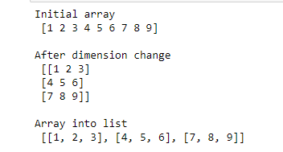**

**CHANGING DIMENSION OF AN ARRAY**

**Program No:** 1 **Date:**29-08-22

**AIM:**Write a NumPy program to change dimension of an array and convert the numpy array into a list.

**Theoretical Support**

NumPy arrays have an attribute called shape that returns a tuple with each index having the number of corresponding elements.

To convert a NumPy array (ndarray) to a Python list use ndarray.tolist() function, this doesn’t take any parameters and returns a python list for an array. While converting to a list, it converts the items to the nearest compatible built-in Python type

**Code**

import numpy as np

x=np.array([1, 2, 3, 4, 5, 6, 7, 8,9])

print("Initial array\n",x)

x.shape=[3,3]

print("\nAfter dimension change\n",x)

y=x.tolist()

print("\nArray into list\n",y))

**Inference**

We can change the dimension of an array using array attribute shape.Dimension can be changed according to the number of elements in the array.Array can be converted into list using tolist().

**Results and Observations**

**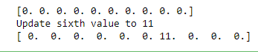**

**CREATE AND UPDATE A NULL NUMPY ARRAY**

**Program No:** 2  **Date:**29-08-22

**AIM:**Write a NumPy program to create and update a null numpy array.

**Theoretical Support**

Numpy.zeros return a new array of given shape and type,filled with zeros.

**Code**

import numpy as np

x = np.zeros(10)

print(x)

print("Update sixth value to 11")

x[6] = 11

print(x)

**Inference**

np.zeros() used for creating null array.Parameter specifies the number of elements that we want to create.Element of an array can be updated using the index value.index start from zero.

**Results and Observations**

**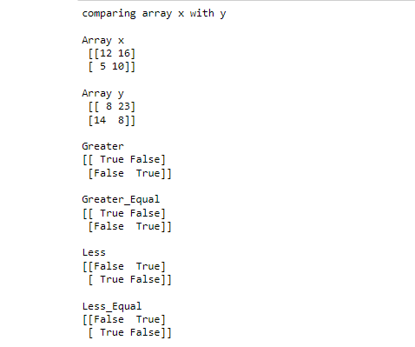**

## EXERCISE 1: INTRODUCTION TO NUMPY CO1

**ELEMENT-WISE COMPARISON OF ARRAYS**

**Program No:** 3  **Date:**29-08-22

**AIM:**Write a NumPy program to create an element-wise comparison(greater,

greater\_equal,less and less\_equal) of two given arrays.

**Theoretical Support**

**numpy.greater()**-To compare and return True if an array is greater than another array.

**numpy.greater\_equal()**-checks whether the elements in a given array (first argument) is

greater than or equal to a specified number(second argument).

**numpy.less(**)-function in Python is used to check, one by one, if the elements of the array x1 are less than the elements of another array x2 that is of the same shape.

**numpy.less\_equal()**-function is used to return the truth value of (x1 =< x2) element-wise.

**Code**

import numpy as np

x = np.array([[12,16],[5,10]])

y = np.array([[8,23],[14,8]])

print("comparing array x with y")

print("\nArray x\n",x)

print("\nArray y\n",y)

print("\nGreater")

print(np.greater(x, y))

print("\nGreater\_Equal")

print(np.greater\_equal(x, y))

print("\nLess")

print(np.less(x, y))

print("\nLess\_Equal")

print(np.less\_equal(x, y))

**Inference**:

numpy comparison functions helps to find the element-wise greater,greater than,lesser,lesser than values of two arrays.Standard mathematical functions for fast operations on entire arrays of data without having to write loops.

**Results and Observations**

**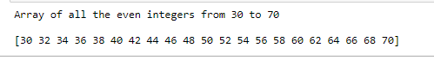**

**ARRAY CREATION**

**Program No:** 4 **Date:**29-08-22

# **AIM:**Write a NumPy program to create an array of all the even integers from 30 to 70.

**Theoretical Support**

**NumPy arange()** is one of the array creation routines based on numerical ranges. It creates an instance of ndarray with evenly spaced values and returns the reference to it.

**Code**

import numpy as np

x=np.arange(30,71,2)

print("Array of all the even integers from 30 to 70\n")

print(x)

**Inference**

Array of even numbers are created easily using numpy.arrange().we can create array of any range of values according to the parameter specified inside the arrange() function.

**Results and Observations**

**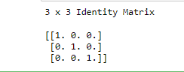**

**IDENTITY MATRIX**

**Program No:** 5  **Date:**02-09-22

# **AIM:**Write a NumPy program to create a 3x3 identity matrix

**Theoretical Support**

****numpy.identity(n, dtype = None)** :**Return a identity matrix i.e. a square matrix with ones on the main diagonal.

**Code**

import numpy as np

x=np.identity(5)

print('3 x 3 Identity Matrix\n')

print(x)

**Inference**

identity matrix are created using identity() function according to the parameter.

Identity(5)-creates a matrix with 5 rows and 5 columns with main diagonal elements as 1 and other elements as 0.

**Results and Observations**

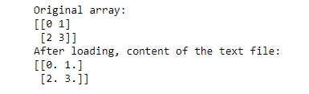

**ARRAY TO TEXT FILE**

**Program No:** 6 **Date:**02-09-22

# **AIM:**Write a NumPy program to save a given array to a text file and load it

**Theoretical Support**

**numpy savetxt** enables you to save a Numpy array to a text file.

Python **numpy loadtxt()** function is used to load the data from a text file and store them in a ndarray.

**Code**

import numpy as np

import os

x = np.arange(4).reshape(2,2)

print("Original array:")

print(x)

header = 'col1 col2'

np.savetxt('temp.txt', x, fmt="%d", header=header)

print("After loading")

result = np.loadtxt('temp.txt')

print(result)

t**emp.txt**

0 1

2 3

**Inference**

Read and wirte contents of a file without using normal file functions.

**Results and Observations**

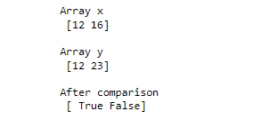

**ARRAY EQUALITY**

**Program No:** 7 **Date:**02-09-22

# **AIM:**Write a NumPy program to check whether two arrays are equal (element wise) or not.

**Theoretical Support**

The **equal()** function is used to return (x1 == x2) element-wise. Input arrays of the same shape

**Code**

import numpy as np

x=np.array([12,16])

y=np.array([12,23])

print("Array x\n",x)

print("\nArray y\n",y)

print("\nAfter comparison\n",np.equal(x,y))

**Inference**

We can compare(element-wise) every elements of a array with another array without using loops.

**Results and Observations**

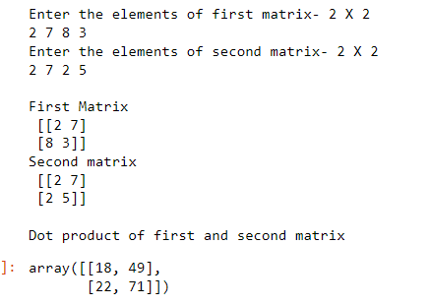

**EXERCISE 2:MATRIX OPERATIONS(USING VECTOIZATION) AND CO1 TRANSFORMATIONS**

**DOT PRODUCT OF MATRIX**

**Program No:** 8  **Date:**05-09-22

**AIM:**Write a python program to create two matrices(read values from user) and find the dot product.

**Theoretical Support**

numpy.dot(vector\_a, vector\_b, out = None) returns the dot product of vectors a and b. It can handle 2D arrays but considers them as matrix and will perform matrix multiplication.

C**ode**

import numpy as np

print("Enter the elements of first matrix- 2 X 2 ");

elements = list(map(int, input().split()));

a= np.array(elements).reshape(2,2);

print("Enter the elements of second matrix- 2 X 2");

elements = list(map(int, input().split()));

b= np.array(elements).reshape(2,2);

print("\nFirst Matrix\n",a)

print("Second matrix\n",b)

print("\nDot product of first and second matrix");

np.dot(a, b)

**Inference**

We can find the dot product of the 2 matrix using numpy.dot() function.During matrix multiplication,we multiply the values of the rows of matrix a with the values of the columns of matrix b and sum them up.

**Results and Observations**

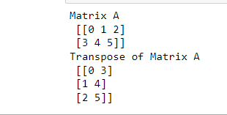

**TRANSPOSE OF MATRIX**

**Program No:** 9 **Date:**05-09-22

**AIM:**Write a python program to find the transpose of the matrix.

**Theoretical Support**

With the help of **Numpy numpy.transpose()**, We can perform the simple function of transpose within one line by using **numpy.transpose()** method of Numpy. It can transpose the 2-D arrays on the other hand it has no effect on 1-D arrays. This method transpose the 2-D numpy array.

C**ode**

import numpy as np

a= np.arange(6).reshape((2,3))

print("Matrix A\n",a)

b=np.transpose(a)

print("Transpose of Matrix A\n",b)

**Inference**

Transpose() converts the row data to the column data and column data to the row data.

**Results and Observations**

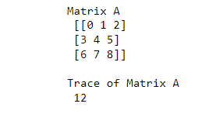

**TRACE OF MATRIX**

**Program No:** 10 **Date:**09-09-22

**AIM:**Write a python program to find the trace of the matrix.

**Theoretical Support**

Trace of the matrix is calculated using **numpy.trace()**.

**Code**

import numpy as np

a= np.arange(9).reshape((3,3))

print("Matrix A\n",a)

b=np.trace(a)

print("\nTrace of Matrix A\n",b)

**Inference**

Numpy.trace() calculate the sum of its digonal elements from the upper left to lower right of matrix.

**Results and Observations**

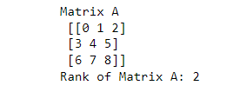

**RANK OF MATRIX**

**Program No:** 11 **Date:**09-09-22

**AIM:**Write a python program to find the rank of the matrix.

**Theoretical Support**

Rank of the matrix is calculated using matrix\_rank() of numpy.

**Code**

import numpy as np

a= np.arange(9).reshape((3,3))

print("Matrix A\n",a)

b=np.linalg.matrix\_rank(a)

print("Rank of Matrix A:",b)

**Inference**

Matrix\_rank() returns the number of linearly independent columns present in the matrix.

**Results and Observations**

**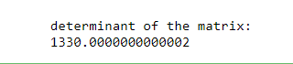**

**DETERMINANT OF MATRIX**

**Program No:** 12 **Date:**09-09-22

**AIM:**Write a python program to find the determinant of the matrix.

**Theoretical Support**

Determinant of the matrix is calculated using det() of numpy.

**Code**

import numpy as np

a = np.array([[50,29], [30,44]])

print("\ndeterminant of the matrix:")

print(np.linalg.det(a))

**Inference**

det(a) will calculate the sum of products of the elements of of any row or column and their corresponding co-factor.

**Results and Observations**

**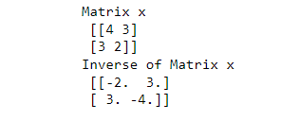**

**INVERSE OF MATRIX**

**Program No:** 13  **Date:**12-09-22

**AIM:**Write a python program to find the inverse of the matrix.

**Theoretical Support**

Inverse of the matrix can be calculated using inv().

**Code**

import numpy as np

x = np.array([[4,3],[3,2]])

y = np.linalg.inv(x)

print("Matrix x\n",x)

print("Inverse of Matrix x\n",y)

**Inference**

Inv() easily find the inverse of the matrix by finding determinant and adjoint.

**Results and Observations**

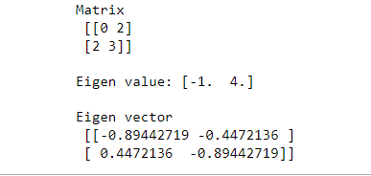

**EIGEN VALUES AND EIGEN VECTORS**

**Program No:**14 **Date:**12-09-22

**AIM:**Write a python program to find the eigen values and eigen vectors..

**Theoretical Support**

Eigen value and eigen vectors are calculated using eig() of numpy.

**Code**

import numpy as np

from numpy.linalg import eig

a = np.array([[0, 2], [2, 3]])

print("Matrix\n",a)

val,vec=eig(a)

print('\nEigen value:', val)

print('\nEigen vector\n', vec)

**Inference**

eig(a) returns two values,first is eigen values and second is eigen vectors.

**Results and Observations**

**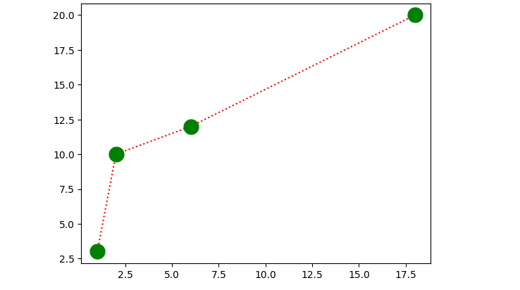**

**EXERCISE 3:PROGRAM USING MATPLOTLIB**

**LINE DIAGRAM**

**Program No:** 15 **Date:**12-09-22

**AIM:**Draw a line in a diagram from position (1, 3) to (2, 10) then to (6, 12) and finally to position  (18, 20). (Mark each point with a beautiful green colour and set line colour to red and line style dotted)

**Theoretical Support**

Line diagram is plotted using plot() of malplotlib.pyplot

**Code**

import matplotlib.pyplot as plt

import numpy as np

xpoints = np.array([1, 2, 6, 18])

ypoints = np.array([3, 10, 12, 20])

plt.plot(xpoints, ypoints,marker='o',color='r',linestyle=':',mfc='g',mec='g',ms='15')

plt.show()

**Inference**

Plt.plot() will plot the xpoints and ypoints in the xy plane with customized line color and size.

**Results and Observations**

**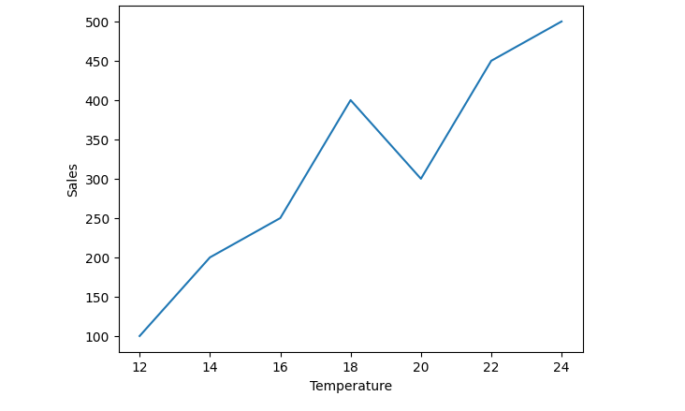**

**PLOT FOR THE GIVEN DATA**

**Program No:** 16  **Date:**16-09-22

**AIM:**Draw a plot for the following data:

|  |  |
| --- | --- |
| **Temperature in degree Celsius** | **Sales** |
| 12 | 100 |
| 14 | 200 |
| 16 | 250 |
| 18 | 400 |
| 20 | 300 |
| 22 | 450 |
| 24 | 500 |

**Theoretical Support**

Line diagram is plotted using plot() of malplotlib.pyplot

**Code**

import matplotlib.pyplot as plt

import numpy as np

xpoints = [12,14,16,18,20,22,24]

ypoints = [100,200,250,400,300,450,500]

plt.plot(xpoints,ypoints)

plt.xlabel("Temperature")

plt.ylabel("Sales")

plt.show()

**Inference**

Plt.plot(xpoints,ypoints) plots xpoints on x-axis and ypoints on y-axis.

**Results and Observations**

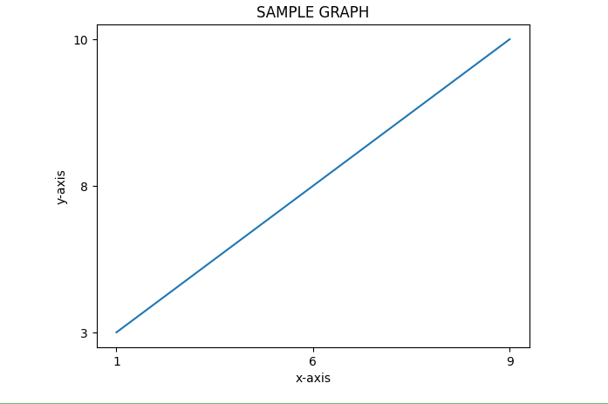

**LINE DIAGRAM USING TEXT FILE**

**Program No:** 17 **Date:**16-09-22

**AIM:**Write a Python program to draw a line using given axis values taken from a text file, with suitable label in the x axis, y axis and a title

**Theoretical Support**

Data from file is readed using read().Data is splited using split().

**Code**

import matplotlib.pyplot as plt

with open("plot.txt") as f:

data = f.read()

data = data.split('\n')

x = [row.split(' ')[0] for row in data]

y = [row.split(' ')[1] for row in data]

plt.plot(x,y)

plt.title("SAMPLE GRAPH")

plt.xlabel("x-axis")

plt.ylabel("y-axis")

plt.show()

**Plot.txt**

1 3

6 8

9 10

**Inference**

Data points from plot.txt is readed and splited into 2 columns using split() and ploted the x values on x-axis and y values on y-axis.

**Results and Observations**

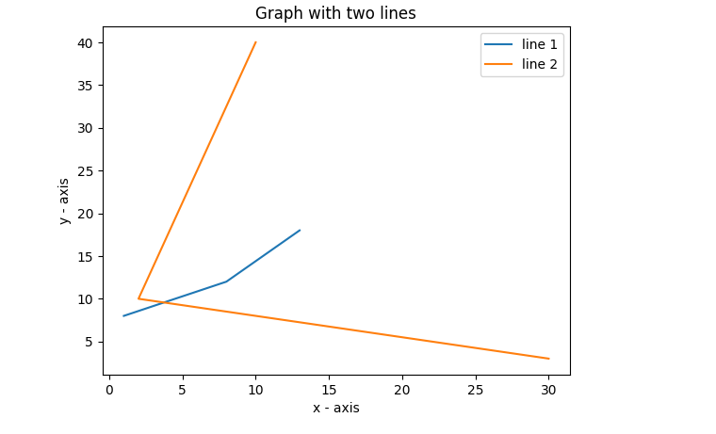

**MULTIPLE LINES ON SAME PLOT**

**Program No:** 18  **Date:**16-09-22

**AIM:**Write a Python program to plot two or more lines on same plot with suitable legends of each line

**Theoretical Support**

Plt.plot() used for creating plots.

**Code**

import matplotlib.pyplot as plt

x1 = [1,8,13]

y1 = [8,12,18]

plt.plot(x1, y1, label = "line 1")

x2 = [10,2,30]

y2 = [40,10,3]

plt.plot(x2, y2, label = "line 2")

plt.title('Graph with two lines')

plt.xlabel('x - axis')

plt.ylabel('y - axis')

plt.legend()

plt.show()

**Inference**

Multiple lines on the same plot can be ploted using plt.plot().first line with x1,y1 points and second line with x2,y2 are plotted.

**Results and Observations**

****

**MULTIPLE PLOTS**

**Program No:** 19 **Date:**19-09-22

**AIM:**Write a Python program to create multiple plots.

**Theoretical Support**

Multiple plots are created using plt.subplot().

**Code**

import matplotlib.pyplot as plt

plt.subplot(2, 3, 4)

plt.xticks(())

plt.yticks(())

plt.subplot(2, 3, 5)

plt.xticks(())

plt.yticks(())

plt.subplot(2, 3, 6)

plt.xticks(())

plt.yticks(())

plt.show()

**Inference**

Each plt.subplot() will create subplots in the main plot.

**Results and Observations**

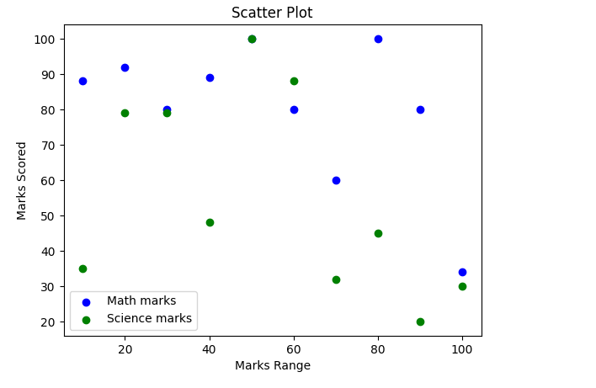

**SCATTER PLOT**

**Program No:** 20 **Date:**19-09-22

**AIM:**Write a Python program to draw a scatter plot comparing two subject marks of Mathematics and Science. Use marks of 10 students.

**Sample data:**

math\_marks = [88, 92, 80, 89, 100, 80, 60, 100, 80, 34]

science\_marks = [35, 79, 79, 48, 100, 88, 32, 45, 20, 30]

marks\_range = [10, 20, 30, 40, 50, 60, 70, 80, 90, 100]

**Theoretical Support**

 The scatter diagram graphs numerical data pairs, with one variable on each axis, show their relationship

**Code**

import matplotlib.pyplot as plt

math\_marks = [88, 92, 80, 89, 100, 80, 60, 100, 80, 34]

science\_marks = [35, 79, 79, 48, 100, 88, 32, 45, 20, 30]

marks\_range = [10, 20, 30, 40, 50, 60, 70, 80, 90, 100]

plt.scatter(marks\_range, math\_marks, label='Math marks', color='b')

plt.scatter(marks\_range, science\_marks, label='Science marks', color='g')

plt.title('Scatter Plot')

plt.xlabel('Marks Range')

plt.ylabel('Marks Scored')

plt.legend()

plt.show(**)**

**Inference**

Plt.scatter will plot the maths\_marks and science mark with marks\_range with custom color.

**CYCLE 2**

**Results and Observations**

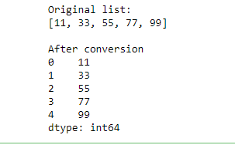

**EXERCISE 4:INTRODUCTION TO PANDAS**

**LIST TO SERIES CONVERSION**

**Program No:** 21 **Date:**23-09-22

**AIM:**Write a python program to implement List-to-Series Conversion.

**Theoretical Support**

List is converted to series using pandas.series().

**Code**

import pandas as pd

list = [11, 33, 55, 77, 99]

print("Original list:")

print(list)

print("\nAfter conversion")

print(pd.Series(list))

**Inference**

Pd.series(list) will convert the list data to series.

**Results and Observations**

**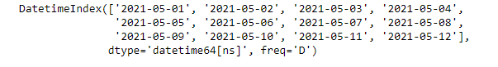**

**GENERATING SERIES OF DATES**

**Program No:** 22 **Date:**23-09-22

**AIM:**Write a python program to Generate the series of dates from 1st May, 2021 to 12th May, 2021 (both inclusive).

**Theoretical Support**

Pandas.date\_range() will create series of date between two ranges.

**Code**

import pandas as pd

result = pd.date\_range(start = '05-01-2021', end = '05-12-2021')

print(result)

**Inference**

pd.date\_range(start = '05-01-2021', end = '05-12-2021') will create series of date between ‘05-01-2021’ to ‘05-12-2021’.

**Results and Observations**

**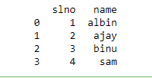**

**DICTIONARY TO DATA FRAME**

**Program No:** 23  **Date:**23-09-22

**AIM:**Given a dictionary, convert it into corresponding dataframe and display it.

**Theoretical Support**

Pandas.dataframe() will convert the data into dataframe.

**Code**

import pandas as pd

data={'slno':[1,2,3,4],'name':['albin','ajay','binu','sam']}

df=pd.DataFrame(data)

print(df)

**Inference**

Pd.dataframe(data) will convert the dictionary to dataframe.

**Results and Observations**

**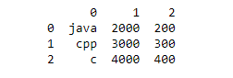**

**LIST TO DATA FRAME**

**Program No:** 24 **Date:**30-09-22

**AIM:**Given a 2D List, convert it into corresponding dataframe and display it.

**Theoretical Support**

Pandas.dataframe() will convert the list to dataframe.

**Code**

import pandas as pd

data = [['java', '2000', '200'],

['cpp','3000','300'],

['c', '4000','400']]

data = pd.DataFrame(data)

print(data)

**Inference**

Pd.DataFrame(data) will convert the list data to dataframe.

**Results and Observations**

**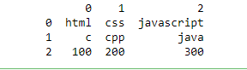**

**CSV FILE TO DATA FRAME**

**Program No:** 25  **Date:**30-09-22

**AIM:**Given a CSV file, read it into a dataframe and display it.

**Theoretical Support**

Csv file is readed using read\_csv() of pandas.

**Code**

import pandas as pd

data = pd.read\_csv ('sample.csv',header=None)

df=pd.DataFrame(data)

print(df)

**Sample.csv**

html html html

c cpp java

100 200 300

**Inference**

Pd.DataFrame(data) splits the data into data frames.

**Results and Observations**

**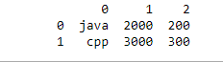**

**DISPLAY FIRST 2 ROWS OF DATA FRAME**

**Program No:** 26  **Date:**10-10-22

**AIM:**Given a dataframe, select first 2 rows and output them.

**Theoretical Support**

Dataframe() of pandas used for creating data frames.

**Code**

import pandas as pd

data = [['java', '2000', '200'],

['cpp','3000','300'],

['c', '4000','400']]

df = pd.DataFrame(data)

print(df.head(2))

**Inference**

df.head(2) will display first 2 rows of the dataframe.

**Results and Observations**

**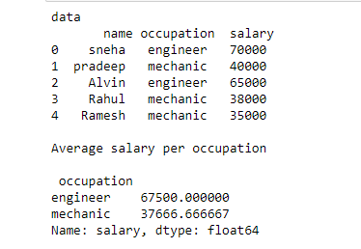**

**AVERAGE SALARY PER OCCUPATION**

**Program No:** 27  **Date:**10-10-22

**AIM:**Given is a dataframe showing name, occupation, salary of people. Find the average salary per occupation.

**Theoretical Support**

read\_csv() used for reading csv file.

**Code**

import pandas as pd

data=pd.read\_csv('people.csv')

print("data\n",data)

print("\nAverage salary per occupation\n\n",data.groupby('occupation')['salary'].mean())

**People.csv**

name occupation salary

sneha engineer 70000

pradeep mechanic 40000

Alvin engineer 65000

Rahul mechanic 38000

Ramesh mechanic 35000

**Inference**

Groupby(occupation) will group the data according to the occupation.

mean() will calculate the average value.

**Results and Observations**

**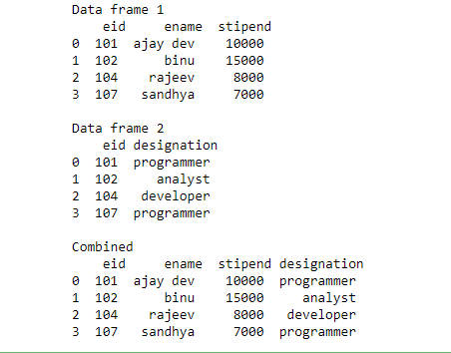**

**DISPLAYING EMPLOYEE DETAILS FROM DATA FRAME**

**Program No:** 28 **Date:**17-10-22

**AIM:**Given are 2 dataframes, with one dataframe containing Employee ID (eid), Employee Name (ename) and Stipend (stipend) and the other dataframe containing Employee ID (eid) and designation of the employee (designation). Output the Dataframe containing Employee ID (eid), Employee Name (ename), Stipend (stipend) and Position (position).

**Theoretical Support**

Pandas.merge() used for merging 2 data frames.

**Code**

import pandas as pd

df1=pd.read\_csv('employee1.csv')

df2=pd.read\_csv('employee2.csv')

print("Data frame 1\n",df1)

print("\nData frame 2\n",df2)

print("\nCombined\n",pd.merge(df1,df2, how = 'inner', on = 'eid'))

**employee1.csv**

eid ename stipend

101 ajay dev 10000

102 binu 15000

104 rajeev 8000

107 sandhya 7000

**employee2.csv**

eid designation

101 programmer

102 analyst

104 developer

107 programmer

**Inference**

Pd.merge(df1,df2) will merge the data frames df1 and df2.

**CYCLE 3**

**Results and Observations**

**Exercise_5**

**EXERCISE 5**

**K-NN CLASSIFICATION**

**Program No:** 29  **Date:**21-10-22

**AIM:**Program to implement **k-NN classification** using any standard dataset available in the public domain and find the accuracy of the algorithm

**Theoretical Support**

The k-nearest neighbors algorithm, also known as KNN or k-NN, is a non-parametric, supervised learning classifier, which uses proximity to make classifications or predictions about the grouping of an individual data point. While it can be used for either regression or classification problems, it is typically used as a classification algorithm, working off the assumption that similar points can be found near one another.

**Dataset used**:iris

**Code**

from sklearn.neighbors import KNeighborsClassifier

from sklearn.model\_selection import train\_test\_split

from sklearn.datasets import load\_iris

irisData=load\_iris()

x=irisData.data

y=irisData.target

X\_train, X\_test, y\_train, y\_test = train\_test\_split(x, y, test\_size = 0.2, random\_state=42)

knn = KNeighborsClassifier(n\_neighbors=7)

knn.fit(X\_train, y\_train)

print("Accuracy")

print(knn.score(X\_test, y\_test))

**Inference**

Dataset is splited into training(80%) and testing(20%) sets. knn.fit() will create the model using training data.

Knn.score() will find the accuracy of the model and a accuracy of 0.966667

**Results and Observations**

**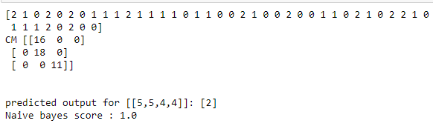**

**EXERCISE 6**

**NAIVE BAYES ALGORITHM**

**Program No:** 30 **Date:**28-10-22

**AIM:**Program to implement **Naïve Bayes Algorithm** using any standard dataset available in the public domain and find the accuracy of the algorithm.

**Theoretical Support**

Naïve Bayes algorithm is a supervised learning algorithm, which is based on ****Bayes theorem**** and used for solving classification problems.It is mainly used in text classification that includes a high-dimensional training dataset.

**Dataset used**:iris

**Code**

from sklearn.datasets import load\_iris

from sklearn.model\_selection import train\_test\_split

from sklearn.naive\_bayes import GaussianNB

X,y=load\_iris(return\_X\_y=True)

X\_train,X\_test,y\_train,y\_test=train\_test\_split(X,y,test\_size=0.30,random\_state=0)

gnb=GaussianNB()

y\_pred=gnb.fit(X\_train,y\_train).predict(X\_test)

print(y\_pred)

x\_new=[[5,5,4,4]]

y\_new=gnb.fit(X\_train,y\_train).predict(x\_new)

from sklearn.metrics import confusion\_matrix

cm = confusion\_matrix(y\_test, y\_pred)

print ("CM", cm)

print("\n")

print("predicted output for [[5,5,4,4]]:",y\_new)

print("Naive bayes score :",gnb.score(X\_test,y\_test))

**Inference**

Data set is splitted into training(70%) and testing sets(30%).gnb.fit() will create the model using training data.Accuracy is obtained using gnb.score() and a accuracy of 1.0 is obtained.

**Results and Observations**

Exercise_7

**EXERCISE 7**

**DECISION TREE**

**Program No:** 31 **Date:**8-11-22

**AIM:**Program to implement **decision trees** using any standard dataset available in the public domain and find the accuracy of the algorithm

**Theoretical Support**

Decision Tree is a ****Supervised learning technique****that can be used for both classification and Regression problems, but mostly it is preferred for solving Classification problems. It is a tree-structured classifier, where****internal nodes represent the features of a dataset, branches represent the decision rules**** and ****each leaf node represents the outcome.****

****Dataset used:**iris**

**Code**

from sklearn.datasets import load\_iris

from sklearn import metrics

from sklearn import tree

import matplotlib.pyplot as plt

from sklearn.model\_selection import train\_test\_split

from sklearn.tree import DecisionTreeClassifier

iris=load\_iris()

x=iris.data

y=iris.target

x\_train,x\_test,y\_train,y\_test = train\_test\_split(x,y,test\_size=0.3,random\_state=1)

clf=DecisionTreeClassifier()

clf=clf.fit(x\_train,y\_train)

y\_pred=clf.predict(x\_test)

print("Accuracy: ",metrics.accuracy\_score(y\_test,y\_pred))

**Inference**

Data set is splitted into training(70%) and testing sets(30%).clf.fit() will create the model using training data.Accuracy is obtained using metrics.accuracy\_score() and a accuracy of 0.9555 is obtained

**Results and Observations**

**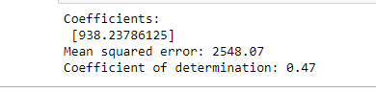**

**EXERCISE 8**

**REGRESSION**

**Program No:** 32  **Date:**18-11-22

**AIM:**Program to implement linear and multiple **regression** techniques using any standard dataset available in the public domain and evaluate its performance

**Theoretical Support**

Regression is **a technique for investigating the relationship between independent variables or features and a dependent variable or outcome**. It's used as a method for predictive modelling in machine learning, in which an algorithm is used to predict continuous outcomes

**Dataset used:**diabetes

**Code**

import matplotlib.pyplot as plt

import numpy as np

from sklearn import datasets, linear\_model

from sklearn.metrics import mean\_squared\_error, r2\_score

df = datasets.load\_diabetes()

diabetes\_X, diabetes\_y = datasets.load\_diabetes(return\_X\_y=True)

diabetes\_X = diabetes\_X[:, np.newaxis, 2]

diabetes\_X\_train = diabetes\_X[:-20]

diabetes\_X\_test = diabetes\_X[-20:]

diabetes\_y\_train = diabetes\_y[:-20]

diabetes\_y\_test = diabetes\_y[-20:]

regr = linear\_model.LinearRegression()

regr.fit(diabetes\_X\_train, diabetes\_y\_train)

diabetes\_y\_pred = regr.predict(diabetes\_X\_test)

print("Coefficients: \n", regr.coef\_)

print("Mean squared error: %.2f" % mean\_squared\_error(diabetes\_y\_test, diabetes\_y\_pred))

print("Coefficient of determination: %.2f" % r2\_score(diabetes\_y\_test, diabetes\_y\_pred))

**Inference**

Linear regression attempts to model the relationship between two variables by fitting a linear equation to observed data.Multiple regression is a statistical technique that can be used to analyze the relationship between a single dependent variable and several independent variables.

**Results and Observations**

**Exercise_9**

**EXERCISE 9**

**SUPPORT VECTOR MACHINE**

**Program No:** 33  **Date:**24-11-22

**AIM:**Program to implement text classification using a **Support vector machine**.

**Theoretical Support**

support Vector Machine or SVM is one of the most popular Supervised Learning algorithms, which is used for Classification as well as Regression problems. However, primarily, it is used for Classification problems in Machine Learning.

**Dataset used:iris**

**Code**

from sklearn.datasets import load\_iris

from sklearn.model\_selection import train\_test\_split

from sklearn import metrics

from sklearn.svm import SVC

iris = load\_iris()

x = iris.data

y = iris.target

x\_train,x\_test,y\_train,y\_test = train\_test\_split(x,y,test\_size=0.3,random\_state=1)

classifier = SVC(kernel='linear', random\_state=0)

classifier.fit(x\_train, y\_train)

y\_pred= classifier.predict(x\_test)

print("Accuracy : ",metrics.accuracy\_score(y\_test,y\_pred))

sample = [[1,1,1,2]]

pred = classifier.predict(sample)

pred\_v = [iris.target\_names[p] for p in pred]

print(pred\_v)

**Inference**

Data set is splitted into training(70%) and testing(30%) sets.

metrics.accuracy\_score() is used for obtaining accuracy and a accuracy of 1.0 is obtained.

**Results and Observations**

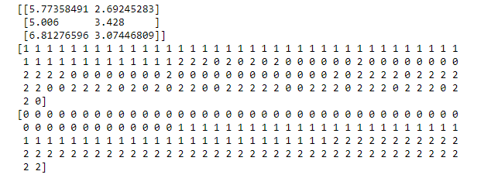

**EXERCISE 10**

**K-MEANS CLUSTERING**

**Program No:** 34  **Date:**02-12-22

**AIM:**Program to implement **k-means clustering** technique using any standard dataset available in the public domain

**Theoretical Support**

Clustering is a type of unsupervised learning where the references need to be drawn from unlabelled datasets. Generally, it is used to capture meaningful structure, underlying processes, and grouping inherent in a dataset. In clustering, the task is to divide the population into several groups in such a way that the data points in the same groups are more similar to each other than the data points in other groups. In short, it is a collection of objects based on their similarities and dissimilarities.

**Dataset used**:iris

**Code**

from sklearn import datasets

import matplotlib.pyplot as plt

import pandas as pd

from sklearn.cluster import KMeans

iris = datasets.load\_iris()

X = iris.data[:, :2]

y = iris.target

km = KMeans(n\_clusters = 3, init='k-means++', n\_init=10, max\_iter=300, tol=0.0001, verbose=0, random\_state=21, copy\_x=True, algorithm="auto")

km.fit(X)

centers = km.cluster\_centers\_

print(centers)

new\_labels = km.labels\_

print(new\_labels)

print(y)

**Inference**

K-means algorithm identifies *k* number of centroids, and then allocates every data point to the nearest cluster, while keeping the centroids as small as possible.The *‘means’* in the K-means refers to averaging of the data; that is, finding the centroid.